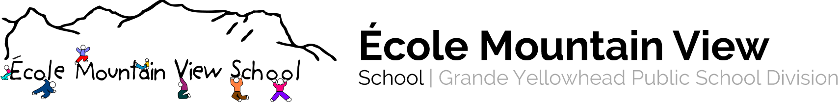
141 MacLeod Avenue Hinton, Alberta T7V 1T6 (780) 865-2628

Course Name: Science 4
Teacher : Rachel Hendricks, Deanna Cederstrand

Program Rationale and Philosophy:
- Students will show independence and the ability to work with others in exploratory activities and, with the guidance, a beginning level of independence in investigating questions and problems. Students should be able to recognize the purpose of most steps followed in investigating questions and problems

Learner Outcomes: Students are expected to:
- Investigate the nature of things, demonstrating purposeful action that leads to inferences supported by observations
- Identify patterns and order in objects and events studied; and record observations, using pictures, words and charts, with guidance in the construction of charts; and make predictions and generalizations, based on observations

Course Content:
- Waste and Our World September – October
- Wheels and Levers November - December
- Light and Shadows January - February
- Building Vehicles that Move March - April
- Plant Growth and Changes May - June

Resources:
- Edmonton Public Schools – Science resource manuals
- Manuel d’évaluation en Sciences 4
- 3V conferences, Bill Nye resources
- Library materials – Hinton Library
- Internet, Local experts

Assessment and Evaluation:
- Formative - Observations, Student Conferencing, Checklists, Anecdotal Records
- Summative assessments – multiple choice and short answers
- Performance Assessments/ Project based learning
- Pamphlets, posters, videos, Slideshows, etc.

