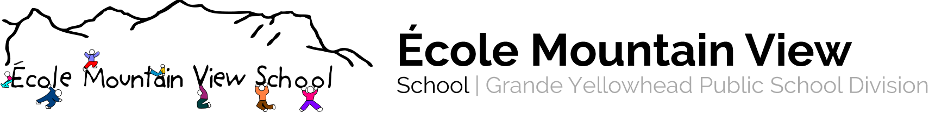
141 MacLeod Avenue Hinton, Alberta T7V 1T6 (780) 865-2628

Course Name: Mathematics 4 Teachers: D. Cederstrand, R. Hendricks

Program Rationale and Philosophy:
- Use mathematics confidently to solve problems
- Communicate and reason mathematically
- Appreciate and value mathematics
- Make connections between mathematics and its application
- Commit themselves to lifelong learning
- Become mathematically literate adults, using mathematics to contribute to society

Learner Outcomes: To achieve the goals of mathematics education and embrace lifelong learning in mathematics, students are expected to:
- Communicate in order to learn and express their understanding
- Connect mathematical ideas to other concepts in mathematics, to everyday experiences and to other disciplines
- Demonstrate fluency with mental mathematics and estimation
- Develop and apply new mathematical knowledge through problem solving
- Develop mathematical reasoning
- Select and use technologies skills to assist in processing information, making connections and solving problems

Course Content: (Projected Timeline- all content is ongoing)
- Measurement – Time/Perimeter & Area September- October
- Geometry- 3D objects/2D Space October-November
- Number Concepts (place value, estimation, addition, subtraction) November-December
- Number Concepts (multiplication, division) January
- Number Concepts (fractions & decimals) February-March
- Patterns and Relations April
- Data Analysis May
- Review June

Resources:
- Compas 4 (Duval), Daily Math 3
- Manipulatives
- Quick Draw/Mental Math for Grade 3 – 5
- Math to the Max- Edmonton Public Schools
- Netmaths App
- Math en Direct (Learn Alberta) http://www.learnalberta.ca/content/mf5ed/html/Math5.html

Assessment and Evaluation:
- Daily work/Observations/Conferencing and Quizzes/Unit Tests/Performance Tests – when applicable

